SQC Guidelines

Table of Contents
1 Introduction 3
2 Descriptive Statistics 3
2.1 Measures of central tendency 3
2.1.1 Mean 3
2.1.2 Median 3
2.1.3 Mode 4
2.2 Measures of variation 4
2.2.1 Range 4
2.2.2 Variance 5
2.2.3 Standard deviation 5
2.2.4 Interquartile range 5
3 Scatter Diagram 6
3.1 When to Use a Scatter Diagram 6
3.2 Scatter Diagram Procedure 7
3.3 Scatter Diagram Considerations 7
4 Histogram 8
4.1 When to Use a Histogram 8
4.2 Histogram Procedure 8
4.3 Histogram Analysis 9
5 Pareto Chart 13
5.1 When to Use a Pareto Chart 13
5.2 Pareto Chart Procedure 13
5.3 Pareto Example 14
6 Fishbone Diagram 15
6.1 When to Use a Fishbone Diagram 15
6.2 Fishbone Diagram Procedure 15
6.3 Fishbone Diagram Example 16
7 Control Chart 17
7.1 When to Use a Control Chart 17
7.2 Control Chart Basic Procedure 17
7.3 Types of Control Chart 19
7.3.1 Xbar and Range Chart 20
7.3.2 X & Moving Range Charts 20
7.3.3 P Charts 20
7.3.4 np Charts 20
7.3.5 C Charts 21
7.3.6 U Charts 21
8 Process Capability Analysis 21
8.1 Process variations 22
8.2 Responding to Variation 23
9 Box and Whisker Plot 24
9.1 Why Use a Box and Whisker Plot? 25
9.2 When to Use a Box and Whisker Plot 25
9.3 A box and whisker plot is developed from five statistics. 25
9.4 Box and Whisker Plot Example 25
10 Hypothesis 27
11 References 32

Introduction
All processes are designed to produce results. The process outputs have measurable attributes that can be observed to describe the quality, quantity, cost and timeliness of the results produced.

Data is collected on efforts, schedule, size, defects pertaining to metrics such as efforts variance, schedule variance, defect density etc. Data needs to be analyzed to identify trends and causes of variations.

Data can be analyzed using statistical tools & techniques like Pareto, Cause & effect diagrams, control charts etc. Few of the statistical tools & techniques are listed below along with the necessary guidelines.

Descriptive Statistics

Measures of central tendency

Mean
The mean (μ) is equal to the sum of n number of observations divided by the number of observations (sample size). Mean is affected by extreme high or low values (outliers) and may not best characterize skewed distributions.

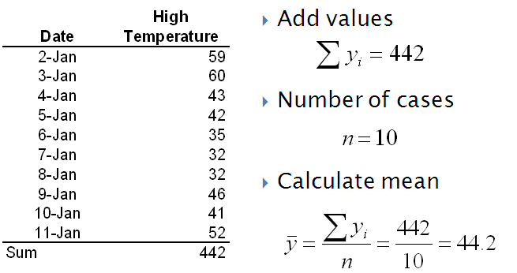

Median
The median represents the middle of the ordered sample data. When the sample size is odd, the median is the middle value. When the sample size is even, the median is the midpoint/mean of the two middle values. The median is the 50th percentile of the data, in that 50% of the data falls above the median, and 50% falls below. The data must be ordered (ranked) to determine the median.

Median requires ordering of values and can be used with both interval and ordinal data. Median is not affected by outliers and better characterizes skewed distributions. For symmetric distributions, the mean and the median are the same. For skewed distributions, the mean lies in the direction of the skew (the longer tail) relative to the median.
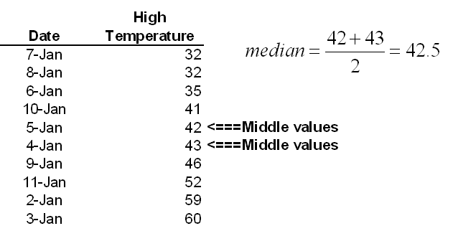

Mode
The mode is the value that occurs most frequently. Mode only involves determination of most common value and can be used with interval, ordinal, and nominal data.
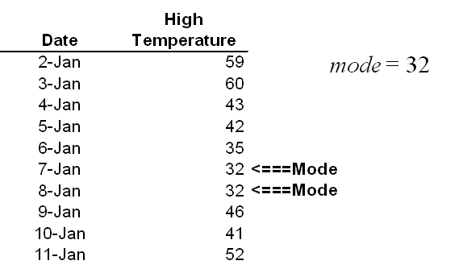

Measures of variation

Range

The range is a rudimentary measure of data dispersion and is the difference between the lowest and highest observation values. Standard deviation is extremely sensitive to extreme values.
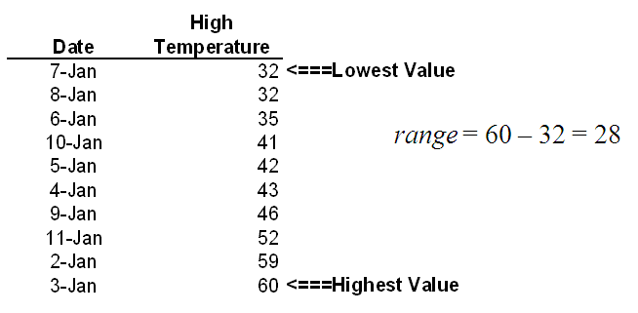

Variance
The variance s2 is the sum of the squared deviations from the mean divided by the number of cases minus 1. In variance square is considered as it gives positive values, gives more weight to larger differences and has desirable statistical properties.

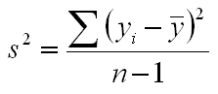

Standard deviation
The standard deviation‘s’ is the square root of the variance. Standard deviation is very sensitive to extreme values.
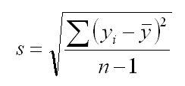
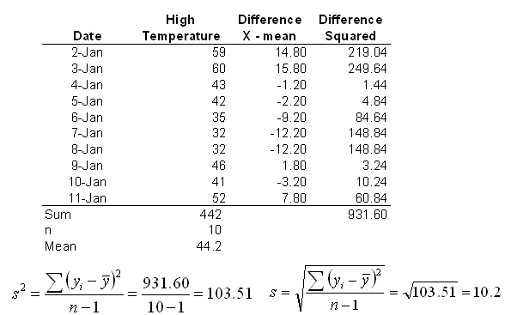

Interquartile range

Interquartile range Difference between upper (third) and lower (first) quartiles. Interquartile range is not sensitive to extreme values.
Quartiles divide data into four equal groups
- Lower (first) quartile is 25th percentile
- Middle (second) quartile is 50th percentile and is the median
- Upper (third) quartile is 75th percentile

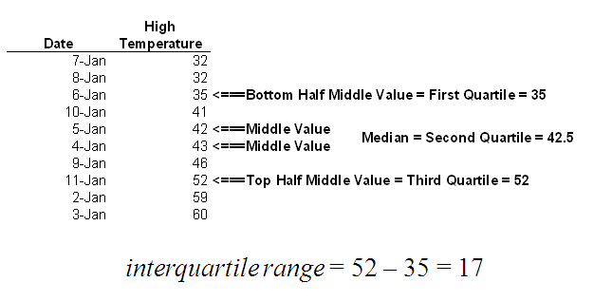
Value can be considered to be an outlier if it falls more than 1.5 times the interquartile range above the upper quartile or more than 1.5 times the range below the lower quarter.
Example for high temperatures
Interquartile range is 17, 1.5 times interquartile range is 25.5
Outliers would be values
- Above 52 + 25.5 = 77.5 (none)
- Below 35 – 25.5 = 9.5 (none)

Scatter Diagram
The scatter diagram graphs pairs of numerical data, with one variable on each axis, to look for a relationship between them. If the variables are correlated, the points will fall along a line or curve. The better the correlation, the tighter the points will hug the line. It is also called as scatter plot, X–Y graph.

When to Use a Scatter Diagram
- When you have paired numerical data.
- When your dependent variable may have multiple values for each value of your independent variable.
- When trying to determine whether the two variables are related, such as…
- When trying to identify potential root causes of problems.
- After brainstorming causes and effects using a fishbone diagram, to determine objectively whether a particular cause and effect are related.
- When determining whether two effects that appear to be related both occur with the same cause.
- When testing for autocorrelation before constructing a control chart.

Scatter Diagram Procedure
- Collect pairs of data where a relationship is suspected.
- Draw a graph with the independent variable on the horizontal axis and the dependent variable on the vertical axis. For each pair of data, put a dot or a symbol where the x-axis value intersects the y-axis value. (If two dots fall together, put them side by side, touching, so that you can see both.)
- Look at the pattern of points to see if a relationship is obvious. If the data clearly forms a line or a curve, you may stop. The variables are correlated. You may wish to use regression or correlation analysis now.

Scatter Diagram Considerations
Scatter diagrams will generally show one of possible correlations between the variables:
- Strong Positive Correlation The value of Y clearly increases as the value of X increases.
- Strong Negative Correlation The value of Y clearly decreases as the value of X increases.
- Weak Positive Correlation The value of Y increases slightly as the value of X increases.
- Weak Negative Correlation The value of Y decreases slightly as the value of X increases.
- Complex Correlation The value of Y seems to be related to the value of X, but the relationship is not easily determined.
- No Correlation There is no demonstrated connection between the two variables.
Note: Co-relation should not be the only indicator considered for causation.
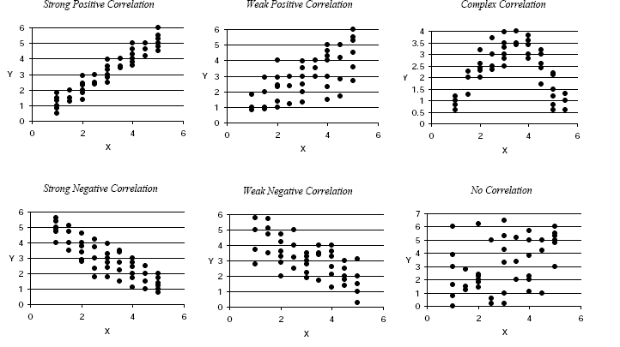

Histogram
A frequency distribution shows how often each different value in a set of data occurs. A histogram is the most commonly used graph to show frequency distributions. It looks very much like a bar chart, but there are important differences between them.

When to Use a Histogram
- When the data are numerical.
- When you want to see the shape of the data’s distribution, especially when determining whether the output of a process is distributed approximately normally
- When analyzing whether a process can meet the customer’s requirements
- When analyzing what the output from a supplier’s process looks like
- When seeing whether a process change has occurred over the time period
- When determining whether the outputs of two or more processes are different.
- When you wish to communicate the distribution of data quickly and easily to others

Histogram Procedure
Step 1. From the raw numbers (the data), find the highest and lowest values. This is known as Range.
Step 2. Determine the number of bars to be used in the histogram. If too many bars are used, the pattern may become lost in the detail; if too few are used, the pattern may be lost within the bars. Table is a guide for choosing an appropriate number of bars.
Step 3. Determine the width of each bar by dividing the range by the number of bars. Then, starting with the lowest value, determine the grouping of values to be contained or represented by each bar.
Number of Data Points | < 50 | 50–100 | 101–250 | > 250
Number of Bars | 5–7 | 6–10 | 7–12 | 10–20
Step 4. Create a compilation table like Table given below and fill in the boundaries for each grouping.
Compilation Table for Constructing a Histogram
Bar | Boundaries | Frequency
Step 5. Fill in the compilation table by counting the number of data points for each bar and calculating the total number of data points in each bar.
Step 6. Draw the horizontal and vertical axes, and label them. The vertical axis of the histogram is labeled Frequency (the number of counts for each bin), and the horizontal axis of the histogram is labeled with the range of your response variable.
Step 7. Draw in the bars to correspond with the totals from the frequency table.
Step 8. Identify and classify the pattern of variation.

Histogram Analysis
Before drawing any conclusions from your histogram, satisfy yourself that the process was operating normally during the time period being studied. If any unusual events affected the process during the time period of the histogram, your analysis of the histogram shape probably cannot be generalized to all time periods. Analyze the meaning of your histogram’s shape.
- Normal: A common pattern is the bell-shaped curve known as the “normal distribution.” In a normal distribution, points are as likely to occur on one side of the average as on the other. Be aware, however, that other distributions look similar to the normal distribution. Statistical calculations must be used to prove a normal distribution.
Don’t let the name “normal” confuse you. The outputs of many processes—perhaps even a majority of them—do not form normal distributions, but that does not mean anything is wrong with those processes. For example, many processes have a natural limit on one side and will produce skewed distributions. This is normal — meaning typical — for those processes, even if the distribution isn’t called “normal”!
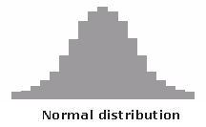
Normal Distribution: A density curve is said to be normal distribution when Mean = Median = Mode. The shape of the normal distribution is bell-shaped and symmetrical across the axis. The area under a density curve is one. The distribution is determined by the mean (μ) and the standard deviation (σ).
- At 1σ area covered under the curve is 68.2%
- At 2σ area covered under the curve is 95.4%
- At 3σ area covered under the curve is 99.7%
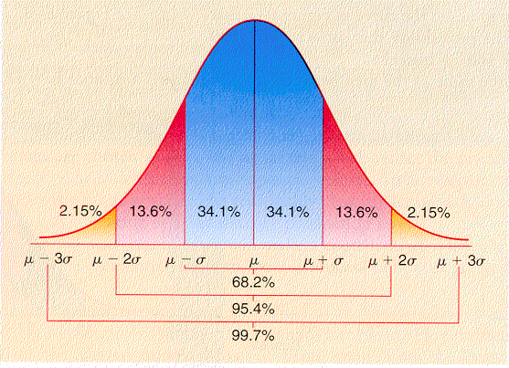
- Skewed: The skewed distribution is asymmetrical because a natural limit prevents outcomes on one side. The distribution’s peak is off center toward the limit and a tail stretches away from it. For example, a distribution of analyses of a very pure product would be skewed, because the product cannot be more than 100 percent pure. Other examples of natural limits are holes that cannot be smaller than the diameter of the drill bit or call-handling times that cannot be less than zero. These distributions are called right- or left-skewed according to the direction of the tail.
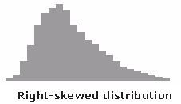
- Double-peaked or bimodal: The bimodal distribution looks like the back of a two-humped camel. The outcomes of two processes with different distributions are combined in one set of data. For example, a distribution of production data from a two-shift operation might be bimodal, if each shift produces a different distribution of results. Stratification often reveals this problem.
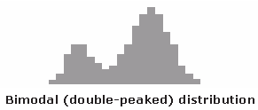
- Plateau: The plateau might be called a “multimodal distribution.” Several processes with normal distributions are combined. Because there are many peaks close together, the top of the distribution resembles a plateau.
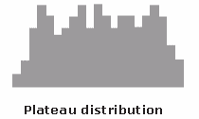
- Edge peak: The edge peak distribution looks like the normal distribution except that it has a large peak at one tail. Usually this is caused by faulty construction of the histogram, with data lumped together into a group labeled “greater than…”
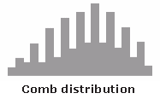
- Truncated or heart-cut: The truncated distribution looks like a normal distribution with the tails cut off. The supplier might be producing a normal distribution of material and then relying on inspection to separate what is within specification limits from what is out of spec. The resulting shipments to the customer from inside the specifications are the heart cut.
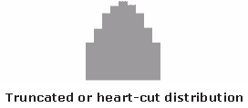
- Dog food: The dog food distribution is missing something—results near the average. If a customer receives this kind of distribution, someone else is receiving a heart cut, and the customer is left with the “dog food,” the odds and ends left over after the master’s meal. Even though what the customer receives is within specifications, the product falls into two clusters: one near the upper specification limit and one near the lower specification limit. This variation often causes problems in the customer’s process.
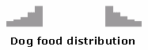
Note: The above patterns are only indicator of potential problem

Pareto Chart
A Pareto chart is a bar graph. The lengths of the bars represent frequency or cost (time or money), and are arranged with longest bars on the left and the shortest to the right. In this way the chart visually depicts which situations are more significant. It is also called as Pareto diagram, Pareto analysis.

When to Use a Pareto Chart
- When analyzing data about the frequency of problems or causes in a process
- When there are many problems or causes and you want to focus on the most significant
- When analyzing broad causes by looking at their specific components
- When communicating with others about your data

Pareto Chart Procedure
- Determine the categories of problems or causes to be compared.
- Select the most meaningful unit of measure such as frequency, cost, defects, errors, cost overruns etc.
- Select the time period over which the data is to be studied.
- Collect the data either by “real time” data gathering or review of historical data.
- Arrange the data in descending order of frequency. Use the template below for data consolidation.
Problem category  (arrange in descending order of frequency) | Frequency | (%) of Total frequency | Cumulative % frequency
A
B
C
D |  |  | 100%
Total |  | 100%
- Create the bar-graph with “problem category” on the X-axis, the frequency on the Y-axis (left) and the “cumulative % frequency” on the Y-axis (right).
- Plot the bars on the Pareto Chart. The problem categories should be marked in decreasing order of frequency from left to right on the X-axis. Draw the frequency histogram.
- Plot the cumulative percentage line.
- Interpret the Pareto chart. Generally the categories having the tallest bars (@60-90% cumulative frequency) indicate the biggest contributors to the problem. Typically, these categories have to be tackled on priority, so that the overall problem is mitigated to a large extent

Pareto Example
The below Pareto has been drawn to represent the distribution of various audit findings (NC) sub-categories and identify the top causes against the CMMI Process Areas.
CMMI Process Area | P1 | P2 | P3 | Grand Total
CM | 16 | 15 | 5 | 36
MA | 3 | 0 | 0 | 3
PP | 30 | 15 | 3 | 48
REQM | 10 | 3 | 3 | 16
IPM | 3 | 2 | 1 | 6
PMC | 14 | 7 | 4 | 25
PPQA | 1 | 0 | 0 | 1
DAR | 1 | 0 | 0 | 1
OPD | 0 | 0 | 0 | 0
OPF | 0 | 0 | 0 | 0
OT | 10 | 8 | 4 | 22
PI | 3 | 2 | 1 | 6
RD | 4 | 0 | 0 | 4
RSKM | 7 | 3 | 4 | 14
TS | 14 | 4 | 1 | 19
VAL | 6 | 4 | 1 | 11
VER | 10 | 7 | 1 | 18
OPP | 0 | 0 | 0 | 0
QPM | 0 | 0 | 0 | 0
CAR | 0 | 0 | 0 | 0
OPM | 0 | 0 | 0 | 0
Grand Total | 132 | 70 | 28 | 230
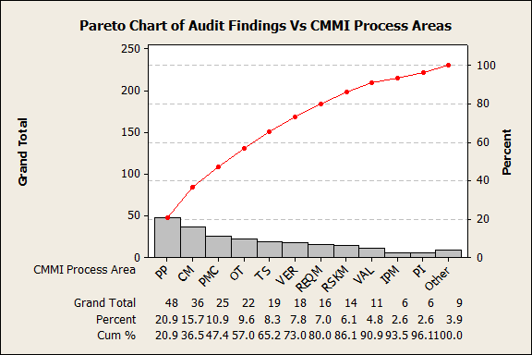

Fishbone Diagram
The fishbone diagram identifies many possible causes for an effect or problem. It can be used to structure a brainstorming session. It immediately sorts ideas into useful categories. Fishbone diagram is also called as Cause-and-Effect Diagram, Ishikawa Diagram, Cause enumeration diagram, process fishbone, time-delay fishbone, CEDAC (cause-and-effect diagram with the addition of cards), desired-result fishbone, reverse fishbone diagram.

When to Use a Fishbone Diagram
- When identifying possible causes for a problem
- Especially when a team’s thinking tends to fall into ruts

Fishbone Diagram Procedure
Materials needed: flipchart or whiteboard, marking pens
- Agree on a problem statement (effect). Write it at the center right of the flipchart or whiteboard. Draw a box around it and draw a horizontal arrow running to it.
- Brainstorm the major categories of causes of the problem. If this is difficult use generic headings:
  - Methodology
  - Machines (Hardware)
  - People (Team)
  - Process
  - Measurement
  - Technology
- Write the categories of causes as branches from the main arrow.
- Brainstorm all the possible causes of the problem. Ask: “Why does this happen?” As each idea is given, the facilitator writes it as a branch from the appropriate category. Causes can be written in several places if they relate to several categories.
- Again ask “why does this happen?” about each cause. Write sub causes branching off the causes. Continue to ask “Why?” and generate deeper levels of causes. Layers of branches indicate causal relationships
- When the group runs out of ideas, focus attention to places on the chart where ideas are few.

Fishbone Diagram Example
This fishbone diagram was drawn by SEPG team, which tried to understand the periodic source of defects in subcategories such as Insufficient Code, Inconsistent Code, and Incorrect Condition. The team used the three generic headings to prompt ideas. Layers of branches show thorough thinking about the causes of the problem.
For example:

Control Chart
The control chart is a graph used to study how a process changes over time. Data are plotted in time order. A control chart always has a central line for the average, an upper line for the upper control limit and a lower line for the lower control limit. These lines are determined from historical data. By comparing current data to these lines, you can draw conclusions about whether the process variation is consistent (in control) or is unpredictable (out of control, affected by special causes of variation).
Control charts for variable data are used in pairs. The top chart monitors the average, or the centering of the distribution of data from the process. The bottom chart monitors the range, or the width of the distribution. If your data were shots in target practice, the average is where the shots are clustering, and the range is how tightly they are clustered. Control charts for attribute data are used singly.

When to Use a Control Chart
- When controlling ongoing processes by finding and correcting problems as they occur.
- When predicting the expected range of outcomes from a process.
- When determining whether a process is stable (in statistical control).
- When analyzing patterns of process variation from special causes (non-routine events) or common causes (built into the process).
- When determining whether your quality improvement project should aim to prevent specific problems or to make fundamental changes to the process.

Control Chart Basic Procedure
- Choose the appropriate control chart for your data.
- Determine the appropriate time period for collecting and plotting data.
- Collect data, construct your chart and analyze the data.
- Look for “out-of-control signals” on the control chart. When one is identified, mark it on the chart and investigate the cause. Document how you investigated, what you learned, the cause and how it was corrected.
- Out-of-control signals
  - A single point outside the control limits. In Figure 1, point sixteen is above the UCL (upper control limit).
  - Two out of three successive points are on the same side of the centerline and farther than 2 σ from it. In Figure 1, point 4 sends that signal.
  - Four out of five successive points are on the same side of the centerline and farther than 1 σ from it. In Figure 1, point 11 sends that signal.
  - A run of eight in a row are on the same side of the centerline. Or 10 out of 11, 12 out of 14 or 16 out of 20. In Figure 1, point 21 is eighth in a row above the centerline.
- Obvious consistent or persistent patterns that suggest something unusual about your data and your process.

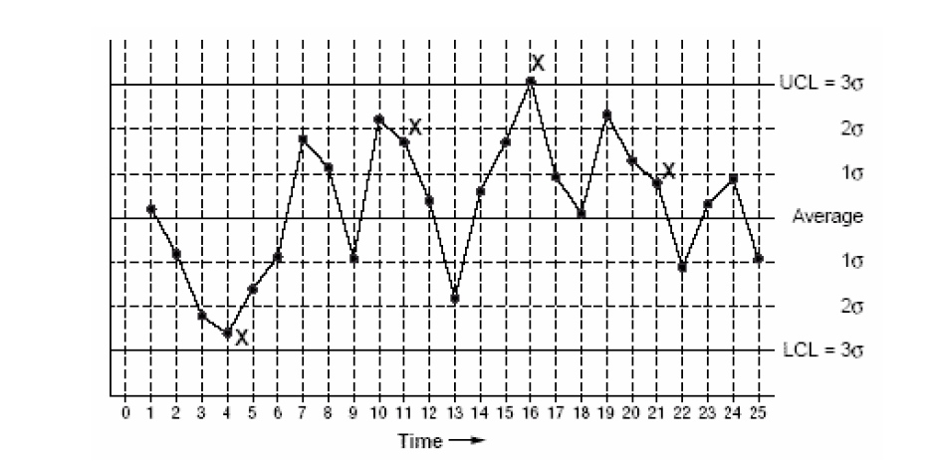
- Continue to plot data as they are generated. As each new data point is plotted, check for new out-of-control signals. When you start a new control chart, the process may be out of control. If so, the control limits calculated from the first 6 points are conditional limits. When you have at least 6 sequential points from a period when the process is operating in control, recalculate control limits

Types of Control Chart
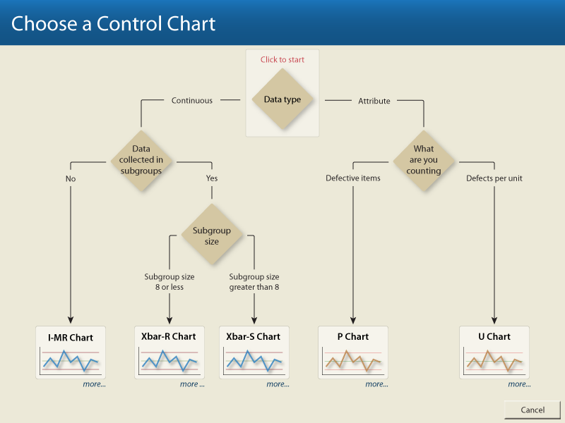

Chart | Process observation | Process observations relationships | Process observations type | Size of shift to detect
and R chart | Quality characteristic measurement within one subgroup | Independent | Variables | Large (≥ 1.5σ)
and s chart | Quality characteristic measurement within one subgroup | Independent | Variables | Large (≥ 1.5σ)
p-chart | Fraction nonconforming within one subgroup | Independent | Attributes | Large (≥ 1.5σ)
np-chart | Number nonconforming within one subgroup | Independent | Attributes | Large (≥ 1.5σ)
c-chart | Number of nonconformances within one subgroup | Independent | Attributes | Large (≥ 1.5σ)
u-chart | Nonconformances per unit within one subgroup | Independent | Attributes | Large (≥ 1.5σ)

    - Xbar and Range Chart

Xbar & Range Charts are the most common control charts used in measuring continuous data. They are fundamental tools used to display the range of variability inherent to a process. By monitoring an Xbar and Range chart, you can determine whether a process is operating consistently or if a special cause has occurred that has changed the operating characteristics of your process. By identifying and eliminating these special causes, you can improve the overall process, which in turn will reduce your scrap and rework numbers, increasing yields.

When to use Xbar & Range Charts

- When data is collected in rational subgroups
- When it is necessary to detect small shifts in process averages
- When it is necessary to detect changes in process variability
    - X & Moving Range Charts

X & Moving Range Charts are common in batch operations where it is unlikely or costly to take more than one sample at a time. Like Xbar & Range charts, they measure continuous data but they may require more data before identifiable patterns can be detected.

When to use X & Moving Range Charts

- Primarily used to track performance over time
- When measurements are expensive (i.e. destructive testing)
- When the output is relatively homogeneous

    - P Charts

P Charts, or percent defective charts, measure discrete data. They are used to quantify defective units. The data is usually collected in samples that are not of constant sizes. Normally subgroup sizes should be larger than 50 and your average number of defects should be equal to or greater than 5. The p-chart chart measures the output of a process as a percentage of defective items. Each item is recorded as either pass or fail, even if the item has more than one defect. This is the most sensitive attribute chart

When to use P Charts

- Primarily used to follow trends and cycles over time
- Used when the subgroup size changes from sample to sample
- Used to evaluate progress after process changes and/or improvements
- Used in cases to quickly and inexpensively gather data
- When there are no specialized skills required to collect the data

    - np Charts

np Charts, or number of defectives chart, are similar to P charts with just a few exceptions. Np Charts are used in cases where the subgroup size remains constant. Np charts are generally easier to understand because they deal with the actual number of defects rather than percentages.

When to use np Charts

- Primarily used to follow trends and cycles over time
- Used when the subgroup size is constant from sample to sample
- Used to evaluate progress after process changes and/or improvements
- Used in cases to quickly and inexpensively gather data
- When there are no specialized skills required to collect the data

    - C Charts

C Charts also measure discrete data. They are used in cases where a single unit is likely to have many defects. The interest here is not only that the item is defective but also in how many defects it has.

When to use C Charts

- Primarily used to follow trends and cycles over time
- When you can count occurrences, but cannot count non-occurrences
- When the probability of an occurrence is less than 10%
- When occurrences are independent from one another
    - U Charts

U Charts also measure discrete data. They are similar to C charts in that they are used in cases where a single unit is likely to have many defects. The differences are in the calculation of control limits and that the plotted points represent the average number of nonconformities per unit. A U chart is used when the unit size of a subgroup varies from subgroup to subgroup.

When to use U Charts

- Primarily used to follow trends and cycles over time
- When the subgroup size varies from subgroup to subgroup
- When the probability of an occurrence is less than 10 percent
- When occurrences are independent from one another

Process Capability Analysis
The object of the capability analysis is to determine what the process can do if it is operated the way it is designed to be operated. This means that such obvious sources of potential variation will be controlled while the study is conducted.
Run Chart and Control Chart of the Process output helps in determining the stability (if the process is statistically in control or not). It makes little sense to examine the process capability if the process is not in control. Therefore, the first step towards a high-quality process is to bring the process under control.
Shewhart defined control as follows:
A phenomenon will be said to be controlled when, through the use of past experience, we can predict, at least within limits, how the phenomenon may be expected to vary in the future. Here it is understood that prediction within limits means that we can state, at least approximately, the probability that the observed phenomenon will fall within the given limits.

Process variations
- Common Cause of Variation - A source of *Quality* failure that is always present as part of the random *Variation* inherent in the *Process* itself.
Common cause variability is a source of variation caused by unknown factors that result in a steady but random distribution of output around the average of the data. Common cause variation is a measure of the process's potential, or how well the process can perform when special cause variation is removed. Therefore, it is a measure of the process technology. Common cause variation is also called random variation, noise, noncontrollable variation, within-group variation, or inherent variation.
Common cause variation is the remaining variation after removing the special causes (non-normal causes) due to one or more of the 5Ms and an "E" causes (Manpower, Material, Method, Measurement, Machine, and Environment) (Refer to Fish-Bone Method in ‘ Guidelines for Statistical Analysis’ for more information).
- Special Cause of Variation - A source of *Quality* failure that lies outside the *Process*, and so is intermittent, unpredictable, unstable; sometimes called an *Assignable Cause*.
Special cause variation is caused by known factors that result in a non-random distribution of output. Also referred to as "exceptional" or "assignable" variation.
Special cause variation is a shift in output caused by a specific factor such as environmental conditions or process input parameters. It can be accounted for directly and potentially removed and is a measure of process control.

Responding to Variation
- Response to Common Cause
Just because a process is stable, or in statistical control, does not mean that its results are satisfactory. A process may be very consistent, day in and day out making items that are nowhere near specification limits. Or, as the Japanese have done so successfully, variation can be systematically reduced, even in stable processes, enabling a gradual tightening of specification limits, and an overall increase in product quality at lower cost.
Improving a stable process is somewhat more difficult than improving an unstable process because, by definition, a stable process has no special causes of variation that jump out at you, asking to be investigated. Instead, you are faced with the task of looking at all data about the process, not simply what made one point different from the others.
Common causes of variation often lie hidden within the system, and are sometimes assumed to be unavoidable. Yet it is very possible, and often very rewarding, to improve processes and reduce common cause variation. Experience had shown that, amongst the people in and around the process, there are enough ideas for improvements to make a significant impact, even on a sound process.
- Responses to Special Causes
When a process is being affected by special causes of variation, it is called "unstable", or "out of control". Removing special causes when they are harmful (which is most of the time) or integrating them when they are beneficial (which is rare) is an important part of process improvement.
It is easiest to deal with special causes if they are spotted early and the data used to identify them is timely. Tracking down special causes relies heavily on people's memories of what made that occurrence different from all the others. People may quickly forget any unusual circumstances that may have triggered the unusual variation.
When you spot a special cause:
  - The first thing to do is control any damage or problems with an immediate, short-term fix. Be careful not to view this fix as a permanent solution or the process will never be improved.
  - Once a quick fix is in place, search for the cause. Ask people in the process what was different that time. What was out of the ordinary? It might not have been much – an unexpected emergency, a change in schedules, or new materials. The need for this sort of information is part of the reason for collecting very complete data the first time around, noting details and traceability factors about a sample or recorded event.
  - Once you have discovered the special cause, you can develop a longer-term remedy. Most special causes have a negative impact on the output of the process and need to be removed. Occasionally, a special cause can have a positive impact depending on the nature of the process. If this is the case, finds ways to capture and integrate it into the system.
  - Avoid these mistakes:
- Changing the process to accommodate the special cause. This usually adds cost and bureaucracy.
- Blaming individuals. Not only does everyone make mistakes, but also chances are that the problem would have occurred regardless of individuals involved.
- Exhorting workers to simply "do better." People can only do as well as the system allows them to do.
- It's important not to stop when you've eliminated special causes of variation. You're only halfway, at that point. The next thing is to reduce common cause variation via systematic process improvement.

Box and Whisker Plot
A box and whisker plot is a graphical method of displaying variation in a set of data. In most cases a histogram provides a sufficient display; however, a box and whisker plot can provide additional detail while allowing multiple sets of data to be displayed in the same graph. Some types are called box and whisker plots with outliers.

Why Use a Box and Whisker Plot?
Box and whisker plots are very effective and easy to read. They summarize data from multiple sources and display the results in a single graph. Box and whisker plots allow for comparison of data from different categories for easier, more effective decision-making.

When to Use a Box and Whisker Plot
Use box and whisker plots when you have multiple data sets from independent sources that are related to each other in some way. Examples include test scores between schools or classrooms, data from before and after a process change, similar features on one part such as cam shaft lobes, or data from duplicate machines manufacturing the same products.

A box and whisker plot is developed from five statistics.
- Minimum value – the smallest value in the data set
- Second quartile – the value below which the lower 25% of the data are contained
- Median value – the middle number in a range of numbers
- Third quartile – the value above which the upper 25% of the data are contained
- Maximum value – the largest value in the data set

Box and Whisker Plot Example
For example, given the following 20 data points, the five required statistics are displayed.
Number | Data
1 | 113 | Minimum: 113
2 | 116
3 | 119
4 | 121
5 | 124
 |  | 2nd Quartile: 124
6 | 124
7 | 125
8 | 126
9 | 126
10 | 126
 |  | Median: 126.5
11 | 127
12 | 127
13 | 128
14 | 129
15 | 130
 |  | 3rd Quartile: 130
16 | 130
17 | 131
18 | 132
19 | 133
20 | 136 | Maximum: 136
Note that for a data set with an even number of values, the median is calculated as the average of the two middle values.
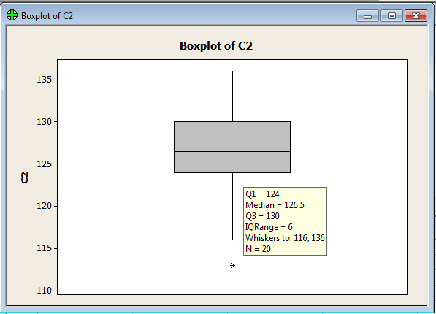
In the above picture the data is represented in box and whisker plot format.
Suppose you wanted to compare the performance of three lathes responsible for the rough turning of a motor shaft. The design specification is 18.85 +/- 1.0 mm.
Diameter measurements from a sample of shafts taken from each roughing lathe are displayed in a box and whisker plot.
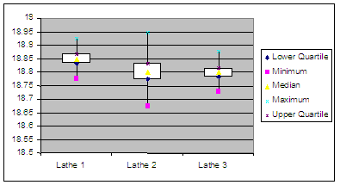
Lathe 1 appears to be making good parts, and is centered in the tolerance.
Lathe 2 appears to have excess variation, and is making shafts below the minimum diameter.
Lathe 3 appears to be performing comparably to Lathe 1. However, it is targeted low in the tolerance, and is making shafts below specification

Hypothesis
Hypothesis testing or significance testing is a method for testing a claim hypothesis about a parameter in a population, using data measured in a sample. In this method, we test some hypothesis by determining the likelihood that a sample statistic could have been selected, if the hypothesis regarding the population parameter were true

A Hypothesis is a predetermined theory or supposition about the nature of relationships between variables

Statistical tests can prove (with a certain degree of confidence) whether a relationship exists.

We have two alternatives for hypothesis:

The “null hypothesis” Ho assumes that there are no differences or relationships. This is the default assumption of all statistical tests
The “alternative hypothesis” Ha states that there is a Statistically significant difference or relationship.

Hypothesis testing helps us to :
- Properly handle uncertainty
- Question assumptions and minimize subjectivity
- Prevent the omission of important information
- Manage the risk of decision errors

STEPS TO HYPOTHESIS TESTING:

The goal of hypothesis testing is to determine the likelihood that a population parameter, such as the mean, is likely to be true. In this section, we describe the four steps of hypothesis testing:

Step 1: State the hypotheses.

We begin by stating the value of a population mean in a null hypothesis, which we presume is true. For the children watching TV example, we state the null hypothesis that children in the United States watch an average of 3 hours of TV per week. This is a starting point so that we can decide whether this is likely to be true, similar to the presumption of innocence in a courtroom. When a defendant is on trial, the jury starts by assuming that the defendant is innocent. The basis of the decision is to determine whether this assumption is true. Likewise, in hypothesis testing, we start by assuming that the hypothesis or claim we are testing is true. This is stated in the null hypothesis. The basis of the decision is to determine whether this assumption is likely to be true.

The null hypothesis (H0), stated as the null, is a statement about a population parameter, such as the population mean, that is assumed to be true.
The null hypothesis is a starting point. We will test whether the value stated in the null hypothesis is likely to be true.

Keep in mind that the only reason we are testing the null hypothesis is because we think it is wrong. We state what we think is wrong about the null hypothesis in an alternative hypothesis. For the children watching TV example, we may have reason to believe that children watch more than (>) or less than (<) 3 hours of TV per week. When we are uncertain of the direction, we can state that the value in the null hypothesis is not equal to (≠) 3 hours.

In a courtroom, since the defendant is assumed to be innocent (this is the null hypothesis so to speak), the burden is on a prosecutor to conduct a trial to show evidence that the defendant is not innocent. In a similar way, we assume the null hypothesis is true, placing the burden on the researcher to conduct a study to show evidence that the null hypothesis is unlikely to be true. Regardless, we always make a decision about the null hypothesis (that it is likely or unlikely to be true). The alternative hypothesis is needed for Step 2

An alternative hypothesis (H1) is a statement that directly contradicts a null hypothesis by stating that that the actual value of a population parameter is less than, greater than, or not equal to the value stated in the null hypothesis.
The alternative hypothesis states what we think is wrong about the null hypothesis, which is needed for Step 2.

Step 2: Set the criteria for a decision.

To set the criteria for a decision, we state the level of significance for a test. This is similar to the criterion that jurors use in a criminal trial. Jurors decide whether the evidence presented shows guilt beyond a
reasonable doubt (this is the criterion). Likewise, in hypothesis testing, we collect data to show that the null hypothesis is not true, based on the likelihood of selecting a sample mean from a population (the likelihood is the criterion). The likelihood or level of significance is typically set at 5% in behavioral research studies. When the probability of obtaining a sample mean is less than 5% if the null hypothesis were true, then we conclude that the sample we selected is too unlikely and so we reject the null hypothesis.

Level of significance, or significance level, refers to a criterion of judgment upon which a decision is made regarding the value stated in a null hypothesis. The criterion is based on the probability of obtaining a statistic measured in a sample if the value stated in the null hypothesis were true.
In behavioral science, the criterion or level of significance is typically set at 5%. When the probability of obtaining a sample mean is less than 5% if the null hypothesis were true, then we reject the value stated in the null hypothesis.

The alternative hypothesis establishes where to place the level of significance. Remember that we know that the sample mean will equal the population mean on average if the null hypothesis is true. All other possible values of the sample mean are normally distributed (central limit theorem). The empirical rule tells us that at least 95% of all sample means fall within about 2 standard deviations (SD) of the population mean, meaning that there is less than a 5% probability of obtaining a Sample mean that is beyond 2 SD from the population mean. For the children watching TV example, we can look for the probability of obtaining a sample mean beyond 2 SD in the upper tail (greater than 3), the lower tail (less than 3), or both tails (not equal to 3). Figure 8.2 shows that the alternative hypothesis is used to determine which tail or tails to place the level of significance for a hypothesis test.

Step 3: Compute the test statistic.

Suppose we measure a sample mean equal to 4 hours per week that children watch TV. To make a decision, we need to evaluate how likely this sample outcome is, if the population mean stated by the null hypothesis (3 hours per week) is true. We use a test statistic to determine this likelihood. Specifically, a test statistic tells us how far, or how many standard deviations, a sample mean is from the population mean. The larger the value of the test statistic, the further the distance, or number of standard deviations, a sample mean is from the population mean stated in the null hypothesis. The value of the
test statistic is used to make a decision in Step 4.

The test statistic is a mathematical formula that allows researchers to determine the likelihood of obtaining sample outcomes if the null hypothesis were true. The value of the test statistic is used to make a decision regarding the null hypothesis.

Step 4: Make a decision

We use the value of the test statistic to make a decision about the null hypothesis. The decision is based on the probability of obtaining a sample mean, given that the value stated in the null hypothesis is true. If the probability of obtaining a sample mean is less than 5% when the null hypothesis is true, then the decision is to reject the null hypothesis. If the probability of obtaining a sample mean is greater than 5% when the null hypothesis is true, then the decision is to retain the null hypothesis. In sum, there are two decisions a researcher can make:

- Reject the null hypothesis. The sample mean is associated with a low probability of occurrence when the null hypothesis is true.

- Retain the null hypothesis. The sample mean is associated with a high probability of occurrence when the null hypothesis is true.

The probability of obtaining a sample mean, given that the value stated in the null hypothesis is true, is stated by the p value. The p value is a probability: It varies between 0 and 1 and can never be negative. In Step 2, we stated the criterion or probability of obtaining a sample mean at which point we will decide to reject the value stated in the null hypothesis, which is typically set at 5% in behavioral research. To make a decision, we compare the p value to the criterion we set in Step 2.

A p value is the probability of obtaining a sample outcome, given that the value stated in the null hypothesis is true. The p value for obtaining a sample outcome is compared to the level of significance.

Significance, or statistical significance, describes a decision made concerning a value stated in the null hypothesis. When the null hypothesis is rejected, we reach significance. When the null hypothesis is retained, we fail to reach significance.

When the p value is less than 5% (p < .05), we reject the null hypothesis. We will refer to p < .05 as the criterion for deciding to reject the null hypothesis, although note that when p = .05, the decision is also to reject the null hypothesis. When the p value is greater than 5% (p > .05), we retain the null hypothesis. The decision to reject or retain the null hypothesis is called significance. When the p value is less than .05, we reach significance; the decision is to reject the null hypothesis. When the p value is greater than .05, we fail to reach significance; the decision is to retain the null hypothesis.

MAKING A DECISION: TYPES OF ERROR

In Step 4, we decide whether to retain or reject the null hypothesis. Because we are observing a sample and not an entire population, it is possible that a conclusion may be wrong. Table 8.3 shows that there are four decision alternatives regarding the truth and falsity of the decision we make about a null hypothesis:

  - The decision to retain the null hypothesis could be correct.
  - The decision to retain the null hypothesis could be incorrect.
  - The decision to reject the null hypothesis could be correct.
  - The decision to reject the null hypothesis could be incorrect.

We investigate each decision alternative in this section. Since we will observe a sample, and not a population, it is impossible to know for sure the truth in the population. So for the sake of illustration, we will assume we know this. This assumption is labeled as truth in the population in Table 8.3. In this section, we will introduce each decision alternative.

DECISION: RETAIN THE NULL HYPOTHESIS

When we decide to retain the null hypothesis, we can be correct or incorrect. The correct decision is to retain a true null hypothesis. This decision is called a null result or null finding. This is usually an uninteresting decision because the deci­sion is to retain what we already assumed: that the value stated in the null hypoth­esis is correct. For this reason, null results alone are rarely published in behavioral
research.
The incorrect decision is to retain a false null hypothesis. This decision is an example of a Type II error, or b error. With each test we make, there is always some probability that the decision could be a Type II error. In this decision, we decide to retain previous notions of truth that are in fact false. While it’s an error, we still did nothing; we retained the null hypothesis. We can always go back and
conduct more studies.

Type II error, or beta (b) error, is the probability of retaining a null hypothesis that is actually false.

DECISION: REJECT THE NULL HYPOTHESIS

When we decide to reject the null hypothesis, we can be correct or incorrect. The incorrect decision is to reject a true null hypothesis. This decision is an example of a Type I error. With each test we make, there is always some probability that our decision is a Type I error. A researcher who makes this error decides to reject previ­ous notions of truth that are in fact true. Making this type of error is analogous to finding an innocent person guilty. To minimize this error, we assume a defendant is innocent when beginning a trial. Similarly, to minimize making a Type I error, we assume the null hypothesis is true when beginning a hypothesis test.

Type I error is the probability of rejecting a null hypothesis that is actually true. Researchers directly control for the probability of committing this type of error.

An alpha (a) level is the level of significance or criterion for a hypothesis test. It is the largest probability of committing a Type I error that we will allow and still decide to reject the null hypothesis.

Since we assume the null hypothesis is true, we control for Type I error by stating a level of significance. The level we set, called the alpha level (symbolized as a), is the larg­est probability of committing a Type I error that we will allow and still decide to reject the null hypothesis. This criterion is usually set at .05 (a = .05), and we compare the alpha level to the p value. When the probability of a Type I error is less than 5% (p < .05), we decide to reject the null hypothesis; otherwise, we retain the null hypothesis.

The correct decision is to reject a false null hypothesis. There is always some probability that we decide that the null hypothesis is false when it is indeed false. This decision is called the power of the decision­making process. It is called power because it is the decision we aim for. Remember that we are only testing the null hypothesis because we think it is wrong. Deciding to reject a false null hypothesis, then, is the power, inasmuch as we learn the most about populations when we accurately reject false notions of truth. This decision is the most published result in behavioral research.

The power in hypothesis testing is the probability of rejecting a false null hypothesis. Specifically, it is the probability that a randomly selected sample will show that the null hypothesis is false when the null hypothesis is indeed false.

References
- http://www.asq.org/learn-about-quality/data-collection-analysis-tools/overview/overview.html
- http://www.qualityamerica.com/knowledgecente/index.htm
- http://www.spcpress.com

Note: The techniques and its method of generation as briefed above are only from an understanding point of view, the calculation and analysis can be performed using various tool and techniques or in Excel.

